|  |
| --- |
| **WEATHER PREDICTION USING DATASCIENCE** |

**INTRODUCTION:-**

It always works in the background in the whole process of weather prediction. For all individuals and organizations, it is a great deal to know the accurate situation of the weather. Many businesses are directly or indirectly linked to climatic conditions. For instance, agriculture relies on weather forecasting to plan when to plant, irrigate and harvest. Similarly, other occupations like construction work, airport control authorities and many more are dependent on the forecasting of weather. With its help, businesses can work with more accuracy and without any disruptions.

**DATA SCIENCE FOR WEATHER PREDICTION:-**

There are various subprocesses involved in the complete process of data science for weather prediction

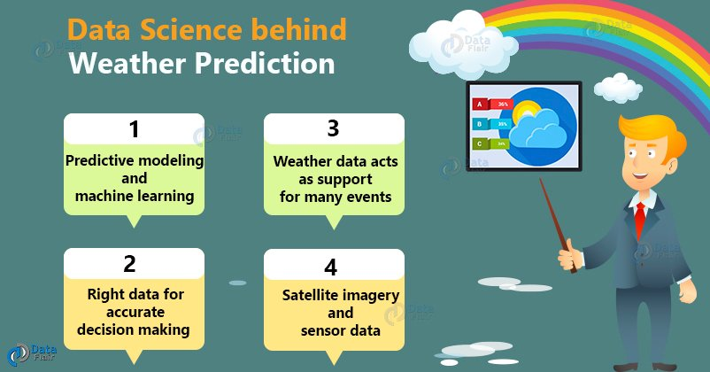

**1.Data – A Crucial Part of Weather Predictions:-**

It is necessary to have the right data to be close to accurate decisions. The data needs to be taken with respect to the location and the time at which it is noted has to be considered.

Today, all the devices are IoT-enabled with gyrometer, barometers and all sorts of sensors in it. So, the location from one standpoint to another is very well available. Therefore, mobile phones proved to be revolutionizing the analytics weather industry and they have really changed the industry

**Advantages of Weather Forecasting:-**

Below are the essential benefits of weather forecasting :

* It helps to deliver visual forecasts by various methods that most companies prefer.
* Organizations can work better with the help of accurate weather predictions.
* Weather forecasting highly benefits the agriculture sector for buying/selling livestock

**Weather Data – An Aid for many Comapanies:-**

**Prediction of Floods and Natural Disasters** :-

Floods and other natural disasters can be predicted by weather data analytics using models. This requires collecting data like the surrounding road condition and the rainfall of the area that year.

**Sports** :-

In sports matches such as cricket, weather like rainfall can lead to delaying or even abandoning the game in between. Weather forecasting can help in deciding the time for matches prior to reducing the chances of pausing the game.

**Predict Asthma Attacks** :-

Weather data can be used to predict severe medical issues such as asthma. The inhalers used during an asthma attack have sensors in them which can gather data to ensure that they are properly used by the patients. It collects data related to the temperature, humidity, air quality, and presence of dust in particular areas (where the patient spends the most time). This information can help reduce the chances of attacks by predicting where asthma can be triggered.

**Conclusion:-**

This was all in data science for weather prediction article. There is still room for many businesses to understand that historical weather data and data science models can help them improve their tactical and strategic decision-making. Data is the new currency, more and more of it exists and so more and more decisions can be made using it.